**Initial Document**

**Optimised Developer Tool -** An OpenGL project utilizing at least 2 of the techniques in the following categories: Geometry shaders, Shadows, Noise, Particle system and animation, Image processing techniques, Physically based reflection model (PBR).

Objective is to create a project that showcases at least 2 of the above techniques combined into one efficient render pipeline. It is perfectly ok to use elements from the first submission (C1) as a start, but you need to show clear contribution beside that initial prototype.

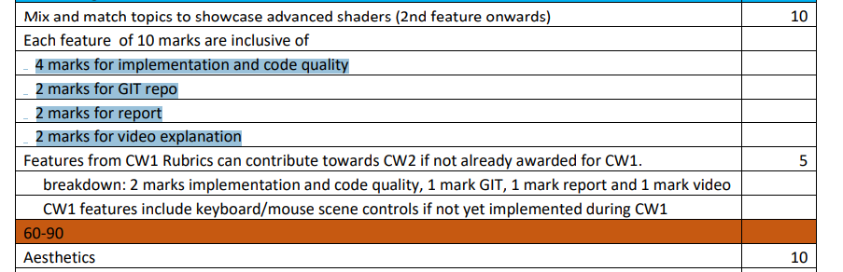

So this is basically saying that 10 marks from 40 then 2 10 marks from this and its broken down like so

So in total 3 - ^^^

**Initial Idea:**

Idea – ( I did this because of the FEEDBACK MORE STUFF WAS ADDED)

**The 3 Techniques I chose:**

* Week 5 - **Bloom Effect** – Simulates bright light bleeding into adjacent areas, creating a glowing effect – Maybe use this for inside can or something
* Week 7 - **Vertex Animations** - Fire/Smoke Particles (Fire/smoke could enhance the broken wall for a more dynamic look)
* Week 10 – **PBR** - Add metal Gun Shine, Or Can idk

**How to Gamify it:**

If i am using the gun for game then maybe make the can shiny instead

I think maybe shooting cans??

Maybe shooting the robot heads in back and score goes up – Timer with fog coming to fill out screen?

You may use any from any sources (i.e. “gamedev”, Nvidia, Shadertoy) of program code which you can adapt. But you must tell us what you started with and what you have done to it. If this is not done you risk failing the assignment. You can also use a wider range of 3rd party libraries this time around, e.g. audio, noise, UI. You could also use a physics library such as a Bullet or PhysX.

**Assets:**

**Models**

Table - <https://www.turbosquid.com/3d-models/low-poly-wooden-table-516990> OR

- <https://www.turbosquid.com/3d-models/old-table-936055>

Can – Already got

Wall - <https://www.turbosquid.com/3d-models/wall-747378>

Gun – Fallout gun - <https://www.turbosquid.com/3d-models/pistol-vintage-sci-fi-1644585>

Backup Gun - <https://www.turbosquid.com/3d-models/beretta-m9-low-poly-pbr-free-1778299>

This could be in background - <https://www.turbosquid.com/3d-models/scifi-913160>

**Audio**

Probably irrklang

**UI**

Probably Inkscape

**What I started with:**

Load the assets , Load the textures, Movement

FEEDBACK FROM CW1

* Need to make sure I have more items and fix skybox